**DESIGN AND IMPLEMENTATION OF AN ONLINE BULLETIN (MANAGEMENT SYSTEM)**

**(A CASE STUDY OF AHMADU BELLO UNIVERSITY SPECIAL BULLETIN)**

**BY**

**RILWAN ABDULLAHI MUHAMMAD D19CSC1101**

**MUHAMMAD AMINA GAMAWA D19CSC1282**

**SOLARIN ABDULRASHEED D18CSC1095**

**SHEHU HAFSAT D19CSC1301**

**MUHAMMAD NUHU DATTI D19CSC1312**

**A PROJECT SUBMITTED TO INSTITUTE OF COMPUTING & ICT, AHMADU BELLO UNIVERSITY ZARIA, IN PARTIAL FULFILMENT OF THE REQUIREMENT FOR THE AWARD OF DIPLOMA IN COMPUTER SCIENCE**

**AHMADU BELLO UNIVERSITY, ZARIA**

**OCTOBER 2022**

DECLARATION

We Rilwan Abdullahi Muhammad, Muhammad Amina Gamawa, Solarin Abdulrasheed, Hafsat Shehu and Hafsat Shehu do hereby declare that this project report entitled “**ONLINE BULLETIN (A CASE STUDY OF AHMADU BELLO UNIVERSITY SPECIAL BULLETIN)**” is a record of project undertaken by us. That we have duly acknowledged all sources of materials conducted and/or included in this project.

RILWAN ABDULLAHI MUHAMMAD **SIGN…………………… DATE……………………**

D19CSC1101

MUHAMMAD AMINA GAMAWA **SIGN…………………… DATE……………………**

D19CSC1282

SOLARIN ABDULRASHEED **SIGN…………………… DATE……………………**

D18CSC1095

SHEHU HAFSAT **SIGN…………………… DATE……………………**

D19CSC1301

MUHAMMAD NUHU DATTI **SIGN…………………… DATE……………………**

D19CSC1312

# CERTIFICATION

This project report titled “**Design and implementation of Online Bulletin (Management System)”** meet the regulation governing the award of Diploma in Computer Science and approved for its contribution to knowledge and literary presentation.

Mrs. M.I Bamidele **-------------------------------** Project Supervisor SIGNATURE & DATE

DR. Odengle J.O **---------------------------**

Chairman, Team of Assessors SIGNATURE & DATE

Mrs. Adewale T. **-------------------------------** Project Co-ordinate SIGNATURE & DATE

Mal. Abdulrahman Abdul **-------------------------------** Head, ETU SIGNATURE & DATE

Dr. A. F. D Kana **-------------------------------** Director SIGNATURE & DATE

# DEDICATION

This project work is dedicated to God Almighty and to our lovely Family who have been with us, both financially and morally with their prayers which have being seeing us through.

And also dedicate the project to all the group members for being hardworking and knowledgeable and not taken offense whatsoever even when we wrong each other at the cause of writing this project.

# ACKNOWLEDGMENT

I acknowledge the king eternal, immortal, invisible, the only wise God through whose mercy, grace and wisdom I was able to complete this work and who saw me through in my academic pursuit. It all ended in praise.

I express my sincere gratitude to my family and remain indebted to my beloved parents for their financial support. Not forgetting my wonderful supervisor for making out time to review this work and all my friends who have contributed to the success of this work. This work would not have been possible without your contributions. May God richly reward you all.

Contents

DECLARATION ii

CERTIFICATION iii

DEDICATION iv

ACKNOWLEDGMENT v

LIST OF FIGURES viii

LIST OF TABLES ix

ABSTRACT x

CHAPTER ONE 1

INTRODUCTION 1

1.1 BACKGROUND OF THE STUDY 1

1.2 STATEMENT OF THE PROBLEM 1

1.3 AIM AND OBJECTIVES 2

1.5 SCOPE OF THE PROJECT 3

CHAPTER TWO 3

LITERATURE REVIEW 3

2.1 INTRODUCTION 3

**2.2 REVIEW OF FUNDAMENTAL CONCEPT** 3

2.3 REVIEW OF EXISTING ONLINE BULLETIN SYSTEMS 5

CHAPTER THREE 7

3.1 INTRODUCTION 7

3.2 SYSTEM ANALYSIS 7

3.2.1 ANALYSIS OF THE EXISTING SYSTEM 8

3.2.2 THE PROBLEMS OF THE EXISTING SYSTEM: 8

3.2.3 ANALYSIS OF THE PROPOSED SYSTEM 9

3.2.4 SYSTEM REQUIREMENTS OF PROPOSED SYSTEM 9

3.3 SYSTEM DESIGN 10

3.3.1 THE SYSTEM ARCHITECTURAL 10

**3.3.2 FLOW CHART** 11

3.3.3 DATABASE DESIGN 12

3.4 SYSTEM IMPLEMENTATION 14

STUDENT REGISTRATION FORM: 17

3. RESULT ANALYSIS AND EVALUATION 22

CHAPTER FOUR 23

**4.1** **CONCLUSION** 23

4.2 **RECOMMENDATION** 23

REFERENCES 24

# LIST OF FIGURES

Figure 3 : System homepage. 17

Figure 4 : User registration 18

Figure 5 : user login page 19

Figure 6 : Student Comment Section 19

Figure 7 : student dashboard. 20

Figure 8 : the password update page. 20

Figure 9 : the profile update page. 21

Figure 10 : Profile update page 21

Figure 11 : the posted bulletin page. 22

**Table 1: User Registration** 13

**Table 2: Bulletin Table** 13

**Table 3: Student comment table** 14

# ABSTRACT

The project is aimed at the development an online news portal for Ahmadu Bello University, Zaria. Some features of the system will be posting news, accepting reader’s opinion (commenting), guest posting and video files. Base on the happenings in the school and special information that needs to get to students and staff in the school. The news and the articles can be accessed by end users through the website URL and administrators can be added through the administrator dashboard which can be located at the website URL.

# CHAPTER ONE

# INTRODUCTION

## 1.1 BACKGROUND OF THE STUDY

One of the most important needs of this age is concise, brief, good, valid and timely information. In most tertiary institutions in Nigeria, for instance, the information unit, is most times, responsible for disseminating information such as announcements, events, lecture and examination schedules, and other reminders from the school management to the academic community. This is sometimes done through notice boards found at various faculties, departments and strategic areas in the institution.

However, the manual method being employed suffers a number of setbacks. Information on notice boards can be distorted, lost and/or destroyed. This information can also be subject to harsh weather conditions like rain and dust as well as conflicts or students’ protest, in which case, vital information on paper is likely to be destroyed or degraded. Though backup paper copies may exist, such copies may never be made available to the teeming populace of the institution for reference purposes when destroyed. To this effect, it is pertinent to deploy a system of information dissemination that can be implemented online over a computer network (such as the internet) to enable users to post, read, and download information such as bulletins, videos and audio messages.

## 1.2 STATEMENT OF THE PROBLEM

The existing manual method used doesn’t allow on-the-go access of information students have to stand in long queues or crowds waiting to have bulletins on wooden notice boards.Also,the information have to be printed and delivered.Some of the delivery is unnecessary;it not only wastes paper and manpower,but also causes environmental protection and document management problems . If the university provide internet services, it will no longer be necessary for information to be printed on paper, thereby saving the natural environment.

## 1.3 AIM AND OBJECTIVES

The aim of this study is to design and implement an online students bulletin. The aim can be achieved through the following objective:

1. To have an effective way of providing information or notifications anywhere and anytime to the students about rapid changes of schedule.
2. To improve the privacy,user-friendliness and to enable convenient access to the different kinds of information and services mounted on the web by users,it would be desirable to set up a portal for channeling the vast information resources to different users in an efficient and effective manner
3. To alleviate the problems and stress of travelling and queuing up of student to check information on the notice board.
4. To create a new forum that supports video and audio files unlike the previous manual bulletin.

1.4 SIGNIFICANCE OF THE STUDY

The design and implementation of an online bulletin system is significant, such significance include:

1. It saves time and money for the university in printing and distributing bulletins on paper.
2. It allows worldwide access; a person may not necessarily have to be in the university or even the country to know what’s happening.
3. Individual department/division can request for the removal of obsolete information on the portal.
4. Allows comments from individuals on posted information.
5. Supports video and audio files unlike the manual/printed bulletin.

## 1.5 SCOPE OF THE PROJECT

This study intends to provide an online news management system web page in which it should contain the description and brief overview about the school-related news for students,staffs and guests of Ahmadu Bello University,Zaria.The scopes of the study are:

1. News about happening in the university.
2. Web-based bulletins.
3. Schedules,announcements and reminders related to the school.

The limitation of the project is that although it covers some of the aspect of an online based bulletin/news management system using Amadu Bello University,Zaria as case study,it does not provide an in-depth study to it’s overall activities.

# CHAPTER TWO

# LITERATURE REVIEW

## 2.1 INTRODUCTION

This chapter focuses on the literature review, the contributions of other researchers pertaining the research topic that is presented in this chapter is under the following headings

**2.2 REVIEW OF FUNDAMENTAL CONCEPT**

**Admin**: Will have access to modules Departments, Result Board, Fees Board and Timetable board. Admin can login and add departments in department module. Can add results in results module which will then show the related info on board. Will upload timetable schedule daily. Admin will approve student registration logins / Professors login etc.

**Student Registration:** It will allow students to register. Once registered request will be sent to admin and it will be approved. Approved student login will have the option to view results, fees related info and also access timetable.

**College Profile:** It will allow admin to add all important info related to college. Option will be provided to add information like year of start, no of professors, batches completed, classes, courses offered etc.  Information saved here will be seen on the dashboard of notice board by default for all logins. Will provide an option to add photos or pictures of college. For a student or professor or staff, this module will show info that has been saved and managed by admin. Hence views will be different in case of admin when compared to other login types.

**Subjects**: It will be accessible to admin and it will allow admin to add subjects to the courses that are being covered. Add max marks for each subject that has been registered. Subjects will be added to different courses and hence a flow will be followed for managing courses, subjects, professors teaching that course and subject.

**Staff**: This module will allow registration for staff members other than professors. And provide their information that can be saved in the system.

**Results Board**: It will allow admin to save marks for each subject for a registered student. It will calculate the percentage of marks and other calculations needed. This will be accessible to students and admin with different views. For admin, it will be a view which will allow admin to add marks for subjects for which student

Enrolled. For a student, it will have a view which will allow him or her to view the results.

**Fees Board:** This module will have the option to add fees for different courses offered and then also maintain the fee payment details for students. Whichever students are registered in the application, admin will update fees related info to keep a track of all the related info. For any logged in student, this module will show a grid or UI where in it will clearly show the fees per year, records related fees that has been paid by a student already with date, amount etc. it will also show pending fees amount too. All info that has to be shown has to be maintained by admin. This module is available for both admin and students

**Timetable Board:** This module will have an option to upload timetable info daily as a part of the attachment. Admin can upload a print out which can be viewed by students and professors. This module will be accessed by both admin / professors and students. Timetable uploaded by admin can be viewed by logged in students and professors.

## 2.3 REVIEW OF EXISTING ONLINE BULLETIN SYSTEMS

**Walia, & Gill., (2019),** developed online student bulletin board to engage to students remotely. It’s an incredible platform to organize and share ideas with students. The system is built using python web development library Django, the system achieved the abilityofusing cross-functional virtual bulletin board. It’s just like having a physical cork-board on the classroom walls where students will have fun posting pictures and presenting their ideas in a very systematic way.Corkulous is another excellent virtual cork-board where student can brainstorm and organize tasks in a very interesting manner. Certainly, however the system does not provide academic bulletin and staff bulletin the system only provide class provide for lectures.

**King., (2018),** designed and implemented digital online notice bulletin tool that can be used in online classes or in collaborating with colleagues. The system is implemented using PHP and MYSQL making it easy for organizing and prioritizing the most important and relevant ideas. But the weakness of the system is that it does not enable student to see specific bulletin that is targeting toward them only, student can only view bulletins that are general for the academic community.

**Griffiths, et al., (2020),** developed virtual bulletin board that can establish a community in distance learning. It’s a unique and easy-to-use visualization digital tool. The software system is built using java programming language. The system support multiple browsers that make it extremely accessible to its users. Users can create interactive slates and customize their background colors, shapes, one of the weakness of the system is that it is not a university standard for updating up to data articles.

**Heather, & Lundin, (2019),** implemented user-friendly virtual bulletin board, for sharing information. The system is developed using rapid application development tool QuickBasic for easy implementation. The system accomplishes perfect digital wall displaying for user’s ideas, concepts, projects, and students’ tasks. And it’s quite similar to the most modern day online student bulletin board. Due to the fact that the system is built with outdated development kit, there is bad user experience and interface design in the frontend design of the software.

**Ganesh, (2019),** developed Bulletin board that convey information and encourage participation. The system is built using HTML/CSS, JavaScript and PHP with MYSQL more ever system focuses on brief report, especially an official statement on a matter of public interest issued for immediate publication or broadcast. The limitation of the system is that its inability to create a room for student to share their interest about the academic activities of university.

With all the review we carried on existing project that we have listed their work, specifications, and functionalities, our online student bulletin board offered in software (internet website)-as-service format. This virtual bulletin board has many uses, as its allowance of multimedia uploads provides a massive amount of functional dexterity, the ability to allow student to comment or share any important information to the school. Our system explores more information and facilitate communication.

# CHAPTER THREE

## 3.1 INTRODUCTION

Methodology is the underlying principles and rules that govern a system method; on the other hand it is a systematic procedure for a set of activities. Thus, from these definitions a methodology encompasses the methods used within a study.

## 3.2 SYSTEM ANALYSIS

The goal of this analysis stage is to truly understand the requirement for the new system in other to develop or upgrade system. This work uses the object-oriented approach. The methodology employed is object-oriented analysis and design methodology (OOADM). OOAD is a software engineering approach that models a system as a group of interacting objects. Each object represents some entity of interest in the system being modeled and is characterized by its' class, state (data element), and behavior. A concept in the object-oriented approach enables analysis to break a complex system into smaller manageable modules, work on the modules individually and easily place the modules back together to form an information system. A set of diagrams or models is used to represent various views and functionality of the system and is commonly known as Unified Modeling Language (UML).

### 3.2.1 ANALYSIS OF THE EXISTING SYSTEM

The existing system makes use of the manual method of physically passing information around in the university. Their processes include the following:

* 1. Bulletin boards are developed and placed in a specific location in the university.
  2. Information is prepared by selected individuals or groups in the university.
  3. Messages are manually pasted to the bulletin board in the faculty or departments.
  4. Students physically go to the bulletin boards to read bulletins.

### 3.2.2 THE PROBLEMS OF THE EXISTING SYSTEM:

* 1. The whole process of removing the old bulletin to paste the new bulletin on the bulletin board is time consuming.
  2. It is energy consuming to always go back and forth to read the faculty bulletin board on regular basis.
  3. It is not accessible everywhere at a time.
  4. People mutilate, remove or tear-off bulletin from the bulletin board leaving others uninformed.
  5. There is unregulated display of information.
  6. Leads to littering the school compound with pieces of papers.
  7. Difficulty in storage and no efficient reference to past relevant information posted.
  8. No designated principal in charge of the board since anyone is free to paste materials at their own discretion.

### 3.2.3 ANALYSIS OF THE PROPOSED SYSTEM

The proposed system in this research is an online bulletin Board. This system is a web application which is engaged in providing up-to-date bulletins in video/audio format and written articles and other information mainly for student and staff (academic and nonacademic) in the university. The bulletin board system will take care of the problems identified in the existing system. All the updates like add, delete, view are done by the administrator, so that user will get the update of the current bulletin.

### 3.2.4 SYSTEM REQUIREMENTS OF PROPOSED SYSTEM

**Software Requirements:**

|  |  |
| --- | --- |
| Software | Specification |
| Operating System | Windows 8, 7, 10. |
| Browser | Firefox, Chrome, Explorer |
| Software | PHP, BOOSTRAP 4, HTML**5**, JAVA SCRIPT, |
| Text Editor | Notepad ++ 6.7 |
| Database | MYSQL database management system. |
| Anti-virus | AVAST Anti-Virus |

**Hardware Requirements:**

1. HP Laptop system
2. 4GB RAM
3. 500GB Hard disk
4. 2.3 GHz Intel Processor (Core i3)
5. Power Source (Generator, NEPA)
6. Battery (4200mAh, 10.8V)
7. Screen size (1366 x 768 resolution)
8. Keyboard (Standard, Qwerty Keyboard)

## 3.3 SYSTEM DESIGN

Under the design phase, we schemed the software architecture in terms of interface design, output design, security issues along with technology specifications both for the server and environment requirement. Some of the tools we used here included Data Flow Diagrams (DFD) was used to show the flow of information and sequence

Of the events as they occur in the system, Entity Relationship Diagrams (ERD) was used to design the database of the proposed system showing the entities (databases and tables) in the system and the relationships that exist among these entities.

### 3.3.1 THE SYSTEM ARCHITECTURAL

The architectural design gives a high-level view of the new system with the main components of the system and services they provide as well as how they communicate. The system using a three-tier architecture that encompasses of user interfaces, process management and DBMS as illustrated below. This structure ensures that users’ interaction with the system is independent of storage consideration.

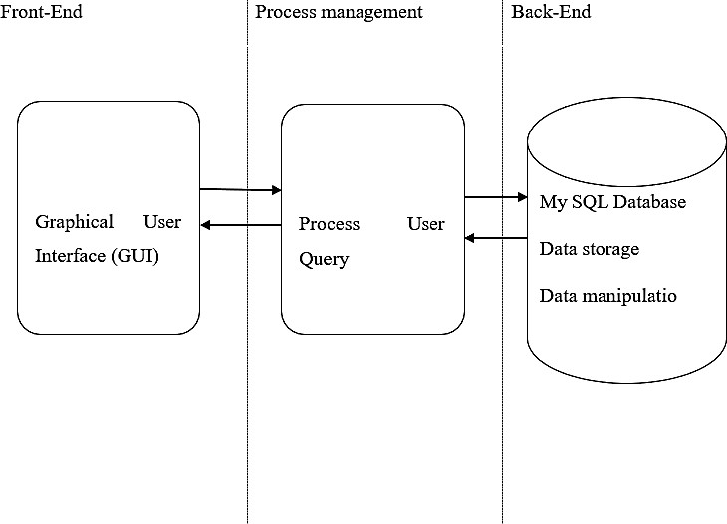

Figure 1: system architecture

**3.3.2 FLOW CHART**

Flow chart is the logical representation of the data flow of this work. The flow chart diagram depicts the stepwise activities of all users in the online bulletin board after registration. Shows the flow chart of the proposed system, where by the flow of data from external entities into the system and how data moved from one process to another is well elaborated.



No

[Form is valid]

[Form is invalid]

Submit Registration Form

Fill in Registration Form



[User has already registered]

[User has not registered]

Click Register

Login

Figure 2: Flowchart Diagram of the system.

### 3.3.3 DATABASE DESIGN

The database management system program used in MYSOL. It is an open source relational database management system. It is named for original developer Michael widens’ daughter my. It is based on a structure query language (SQL) which is used for adding, removing and modifying information in a database. Standard SQL commands such as; ADD, DROP, INSERT and UPDATA is used with MYSQL.

**Table 1: User Registration**

|  |  |  |
| --- | --- | --- |
| **NAME** | **DATA TYPE** | **ALLOW NULLS** |
| User ID | VARCHAR | FALSE |
| Username | String() | FALSE |
| Email | VARCHAR | FALSE |
| Password | VARCHAR | FALSE |
| Mobile Number | INT | FALSE |
| Gender | String() | FALSE |
| Hobby | String | FALSE |

**Table 2: Bulletin Table**

|  |  |  |
| --- | --- | --- |
| **NAME** | **DATA TYPE** | **ALLOW NULLS** |
| Bulletin ID | INT | FALSE |
| Bulletin Tittle | String() | FALSE |
| subject | String() | FALSE |
| Description | String() | FALSE |
| Date | Date/Time | TRUE |

**Table 3: Student comment table**

|  |  |  |
| --- | --- | --- |
| **NAME** | **ALLOW TYPE** | **ALLOW NULLS** |
| User ID | INT | FALSE |
| Username | String() | FALSE |
| Email | VARCHAR | FALSE |
| Subject | String() | FALSE |
| Message | String() | FALSE |

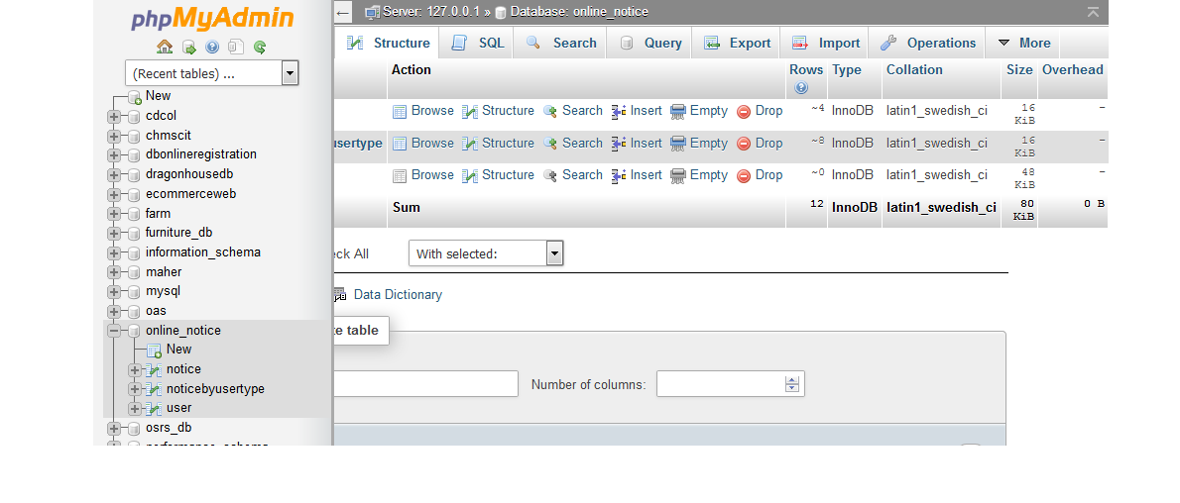

**Figure 5:** the system database design using Xammp server.

## 3.4 SYSTEM IMPLEMENTATION

The development tools are the necessary requirement tools used during the implementation to enable us achieve the system design. The listed packages was used because of their features, accessibility and also because they are more effective.

**HTML Language**: Hypertext Markup Language (HTML), the standard text-formatting language for documents on the interconnected computing network known as the World Wide Web. HTML documents are text files that contain two parts: content that is meant to be rendered on a computer screen; and *markup* or *tags*, encoded information that directs the text format on the screen ace code editor and Notepad replacement that supports several languages. Running in the MS Windows environment, its use is governed by GPL License.

**XAMPP:** MySQL is a popular choice ond is generally hidden from the user.

**Notepad++:** Notepad++ is a free sourf database for use in web applications, and is a central component of the widely used LAMP open source web application software stack—LAMP is an acronym for "Linux, Apache, MySQL, Perl/PHP/Python".

**The system homepage:**

The homepage section consist of sections where student can register new account, logging section, student comment box and video/audio bulletin section (multimedia)

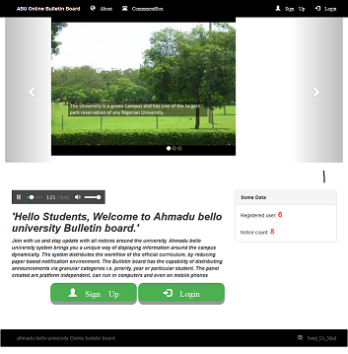

**Figure 3****: System homepage.**

# STUDENT REGISTRATION FORM:

Through the homepage student can register to the bulletin system, the registration form is located under the multimedia section.

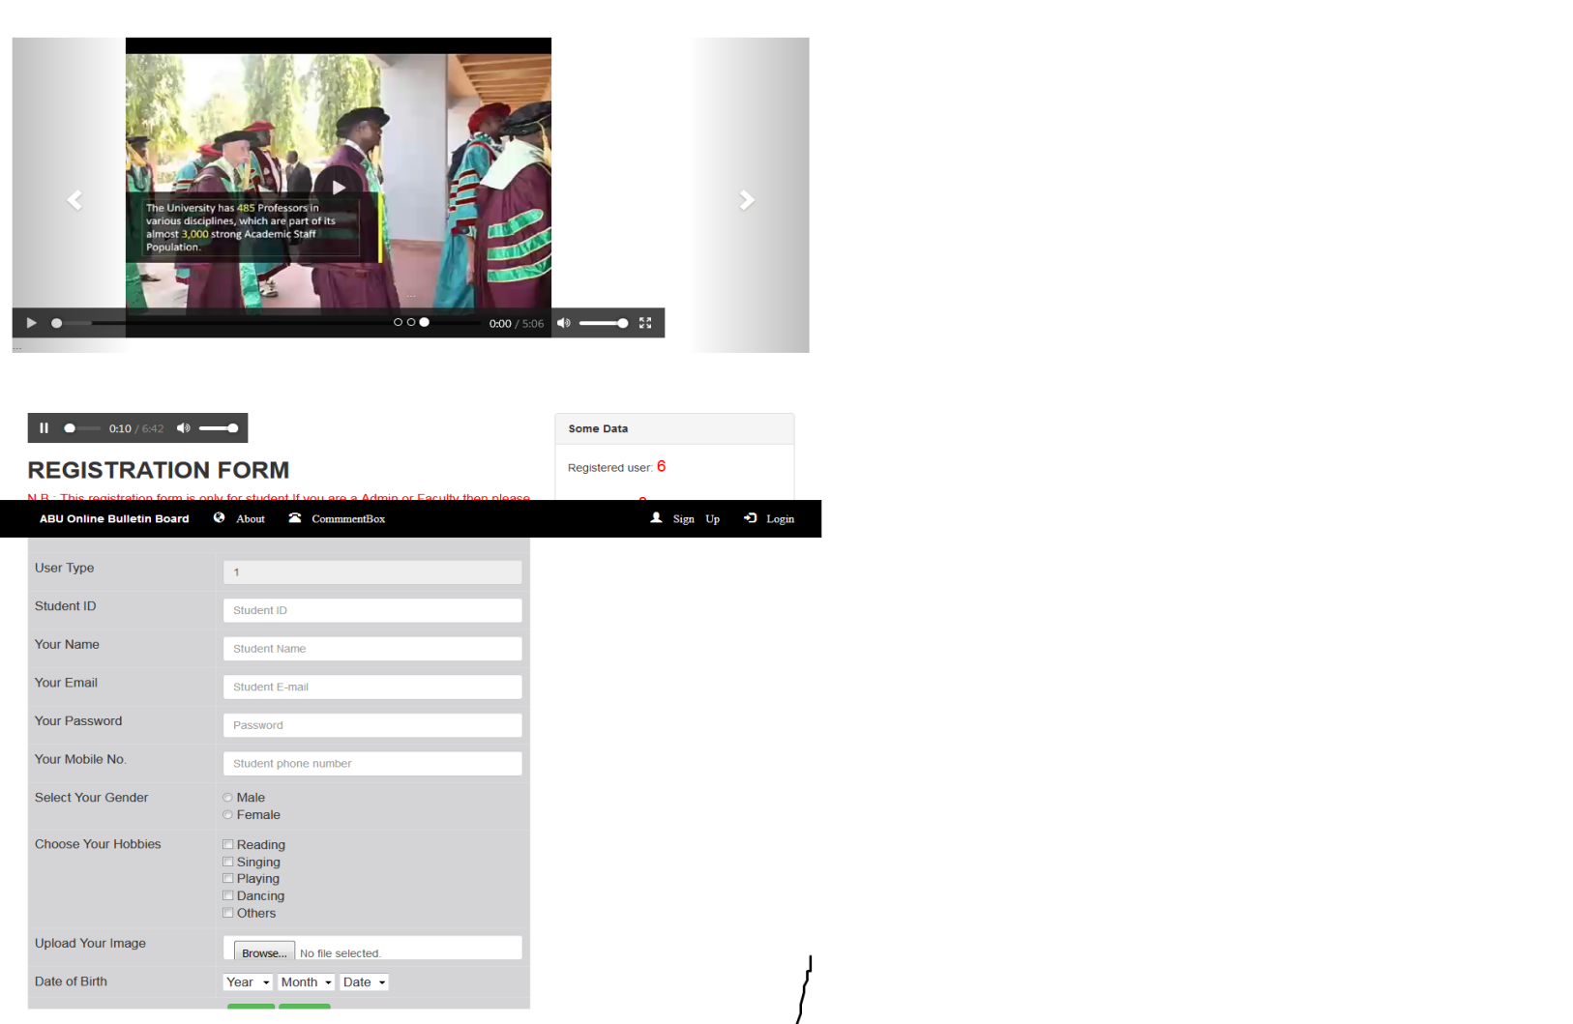

**Figure 4****: User registration**

**User login:**

Through the user logic section students are able to log to the system by using unique email address and password

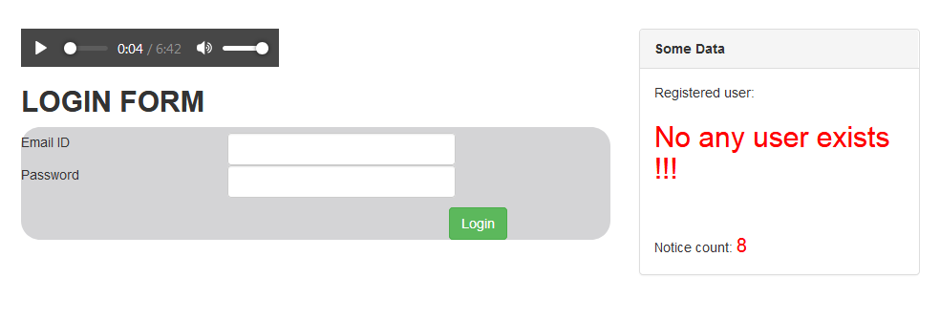

**Figure 5****: user login page**

.

**Student comment:** through this form student can comment about their interest or sharing of any vital information to the school.

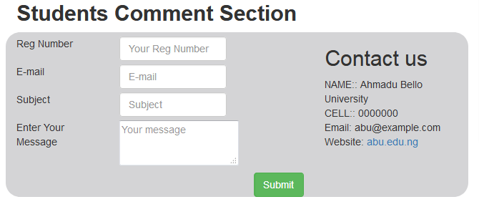

**Figure 6****: Student Comment Section**

.

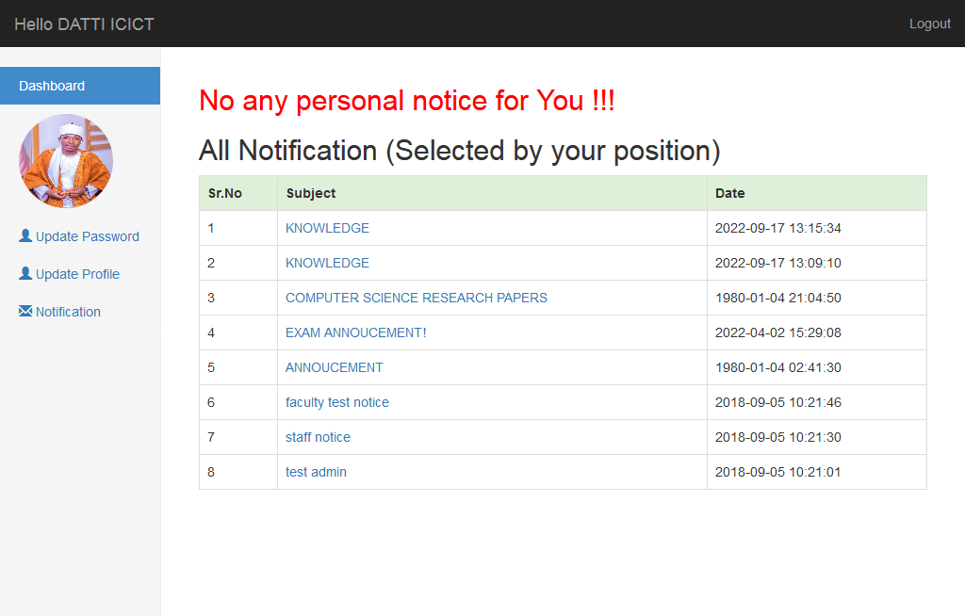

**Figure 7** **: student dashboard.**

**Password update page**:

Through this page students can update their password for security purpose.

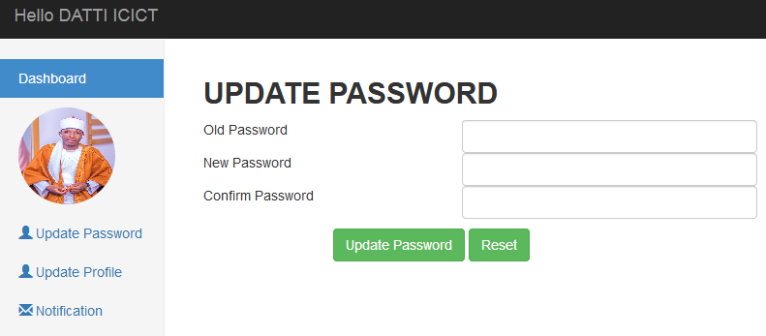

**Figure 8****: the password update page.**

**The profile picture update page:**

Students are able to update their profile picture for clear reference and security matters.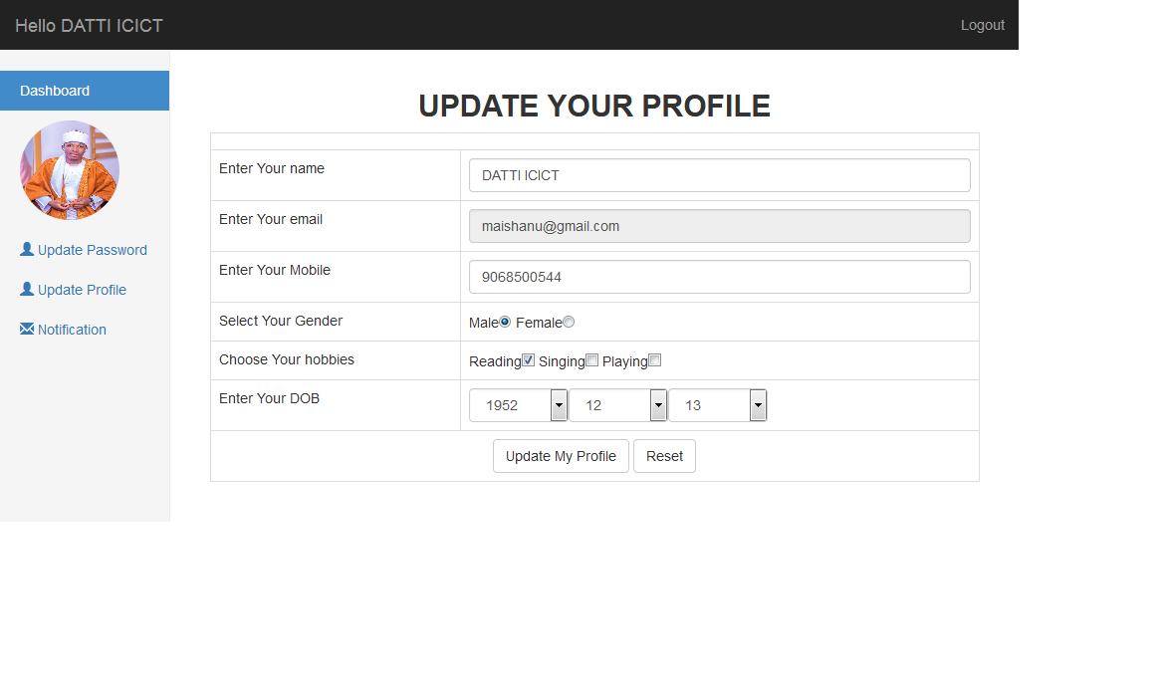 ***Figure 9: the profile update page***

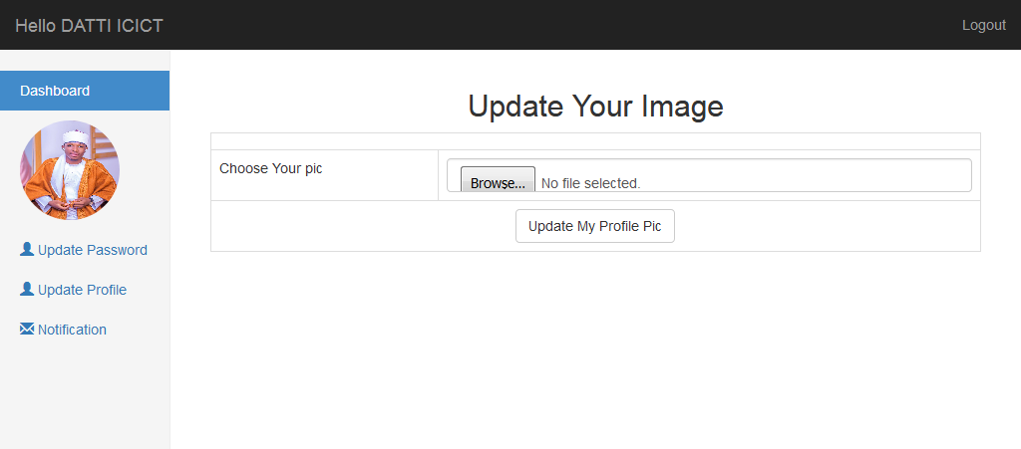

**Figure 10****: Profile update page**

**The Bulletin page**:

The bulletins are posted by admin and users of the system can access them by logging into their unique account.

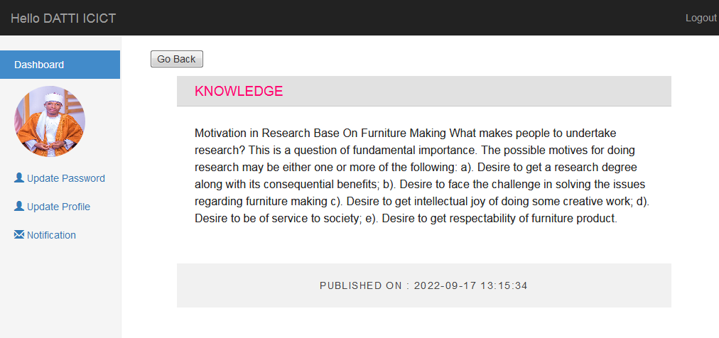

**Figure 11****: the posted bulletin page.**

# 3. RESULT ANALYSIS AND EVALUATION

The deployment of our online bulletin board brings a unique way of displaying information around the campus dynamically. The system distributes the workflow of the official curriculum by reducing paper based notification environment. The online bulletin has the capability of distributing announcement via regular categories. The panel created are platform independent which can run even on mobile phones, the student panel is completely animated that helps to determine importance update. The admin panel support CRUD (create, read update and delete) tools.

**CHAPTER FOUR**

**4.1 CONCLUSION**

The deployment of the ahmadu Bello university bulletin system brings unique way of displaying information around the campus dynamically. The system distributes the workflow of the official curriculum by reducing paper based notification environment. The online bulletin board has the capability of distributing announcements via regular categories i.e. priority, year or particular student. The panel created are platform independent, can run even on important updates. The online bulletin board admin panel support CRUD (Create, Read, Update and Delete) tools. The application also has an archive data section where students can view their previous records. In general the ABU online bulletin board system is a step forward in improving the current manual system and flow of information roaming at the academic institution.

4.2 **RECOMMENDATION**

The application can be very flexible in future research seeing now that we have web 3.0 and the system will be important for various future updates, such as it can contain a camera that will detect users and open their accounts automatically by facial recognition. It can also contain GSM subscription which will send text messages to particular students whenever an update has been made. Also in the future we may see many update like the system server can verify login and grant access to authorized users it can also forward a short message and granting them a link to further investigate the information if they are directly concerned User can then go online at their convenient to read the bulletin in detail and the system can expand its categories to make room for non-academic staff activities.

**REFERENCES**

Walia, E. S., & Gill, E. S. K. (2019). A framework for web based student record management system using PHP. International Journal of Computer Science and Mobile Computing, 3(8), 24-33.

King, K. P. (2018). Educators revitalize the classroom “bulletin board” a case study of the influence of online dialogue on face-to-face classes from an university learning perspective. Journal of research on computing in education, 33(4), 337-354.

Ganesh, E. N. (2019). Implementation of digital notice board using raspberry pi and iot. Oriental journal of computer science and technology, 12(1), 14-20.

Griffiths, K. M., Reynolds, J., & Vassallo, S. (2020). An online, moderated peer-to-peer support bulletin board for depression: user-perceived advantages and disadvantages.

Heather, J., & Lundin, D. (2019, October). The append-only web bulletin board. In International Workshop on Formal Aspects in Security and Trust (pp. 242-256). Springer, Berlin, Heidelberg.